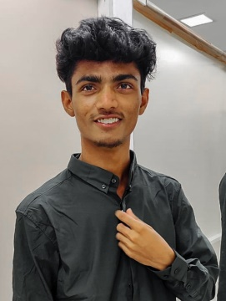**Name** HARIKRISHNA KURUVA

**Address** 4-47-A,Kothapalli(v),Pathikonda(m), Kurnool(dist),516101

**Mobile no.** +916301615610

**Email** [harikrishna055hari@gmail.com](mailto:harikrishna055hari@gmail.com)

**Objective**

Seeking a challenging position in a reputed organization where I can learn new skills, expand my knowledge, and leverage my learnings

**Education**

|  |  |  |  |  |
| --- | --- | --- | --- | --- |
| **Degree** | **Institution** | **Board** | **Year Of Passing** | **Aggregate marks** |
| Bachelor of technology | Sri Venkateswara College Of Engineering & Technology(Autonomous),Chittoor | Jawaharlal Nehru Technological University Ananthapur | 2021-2024(pursuing) | 7.3 |
| Diploma | Sree Vidyanikethan Engineering College (polytechnic) | State Board Of Technical Education And Training | 2017-2020 | 74% |
| 10th Standard | Santhi E.M. High School | Secondary School Education | 2016-2017 | 8.0 |

**Area of interest**

* Network security
* Data base
* Web technology
* testing

**Technical skills**

* Python (Intermediate)
* Java (Beginner)
* HTML (Intermediate)
* Database (Advanced)

**Project**

Completion of project in *Internshala* about to create an fantasy cricket game using python and Qt designer (6 weeks)

**Certificate**

* Certification of Hands on workshop on Data Science and Machine Learning
* Certification of HTML in Edyst
* Certification of python training in Besant Technologies
* Certification of python in Edyst
* Certification of course completion in Internshala with Python
* Certification of angular java script in coursera
* Certification of Java Programming: Solving Problems with Software in courser
* Certification of HTML and CSS in coursera

**Extra-curricular**

* Sports
* Cooking
* Riding bikes

**Personal skills**

* Quick learner
* Positive thinker
* Self motivated
* Patience

**Hobbies**

* Cooking
* Gardening
* Listening music
* Watching movies
* Reading books

**Languages known**

* Telugu and English
* Hindi (Beginner)